**DEVELOPT BY:**  **MOIN AKHTAR Facebook: fb.com/moinakhtar123**

**CELL NO# 03412281694**

**TEACHER: ALI ZAHID**

**APTECH GULSHAN**

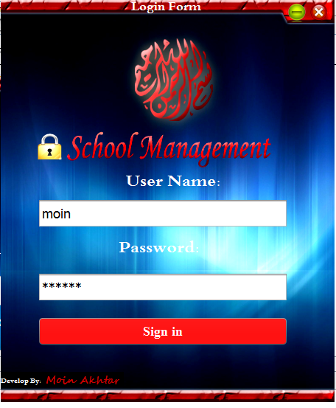

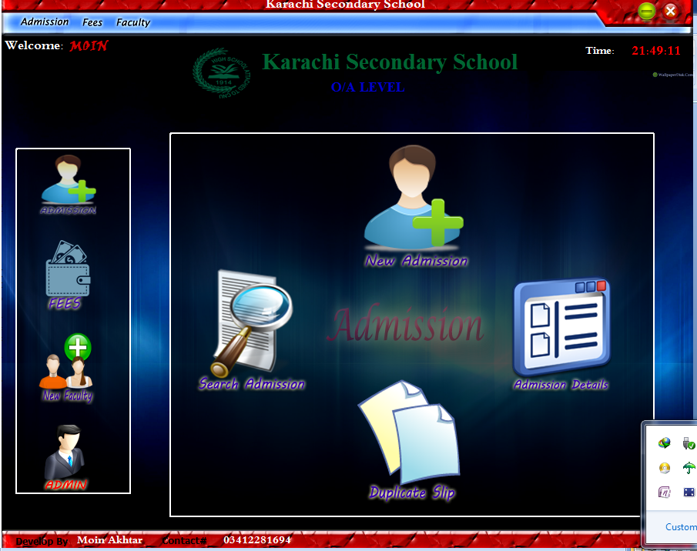

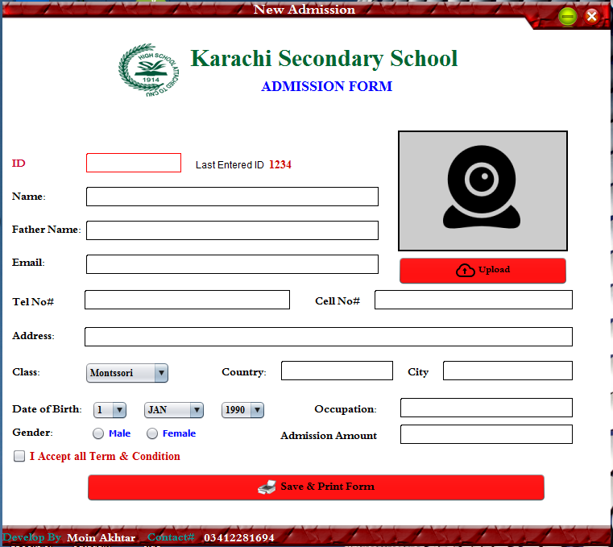

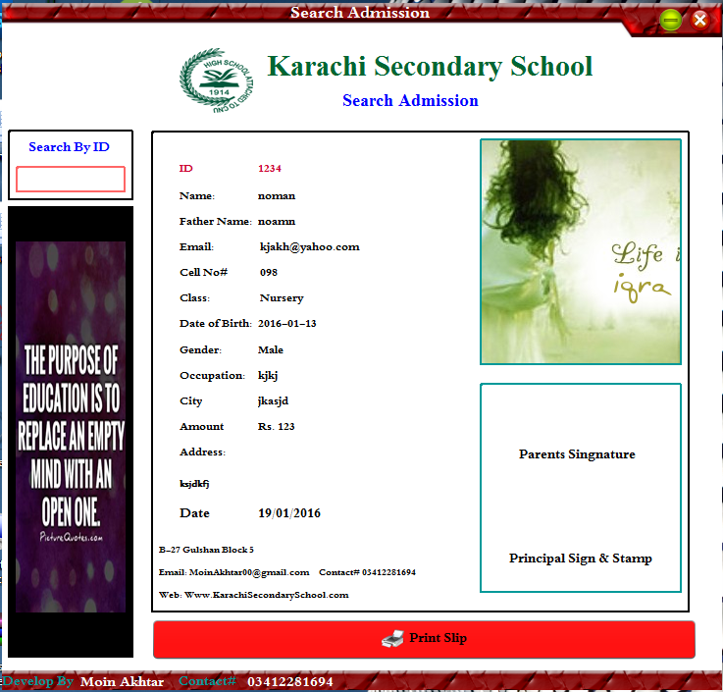

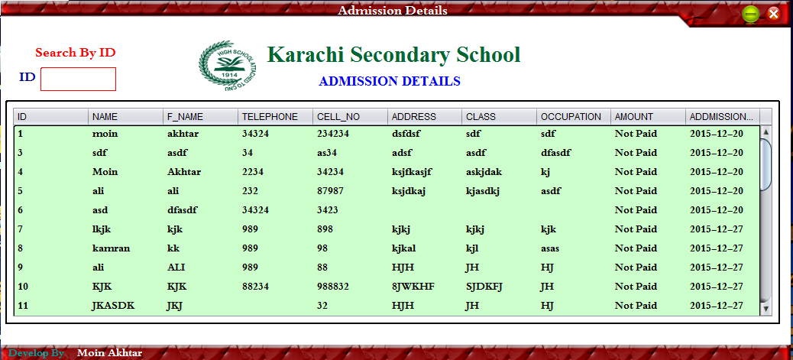

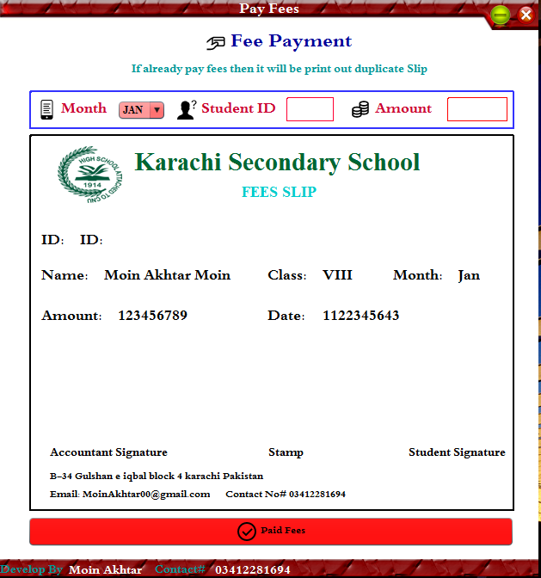

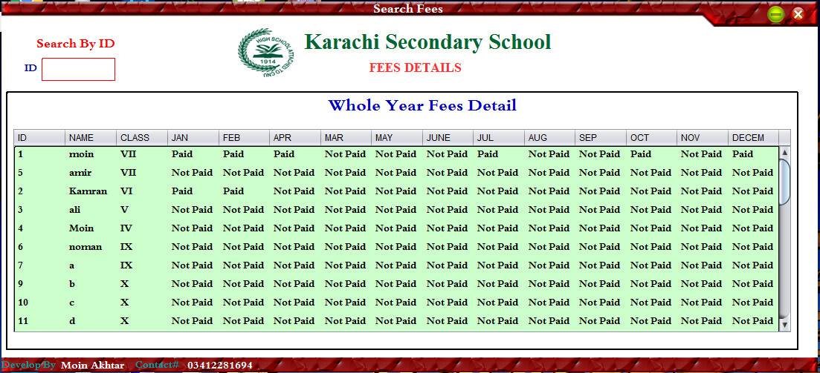

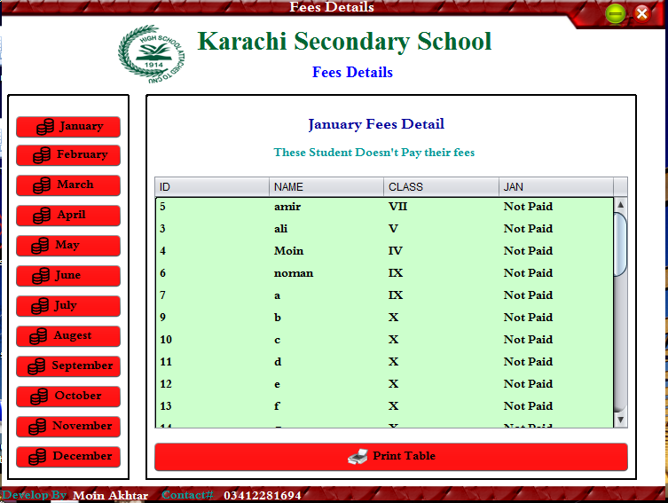



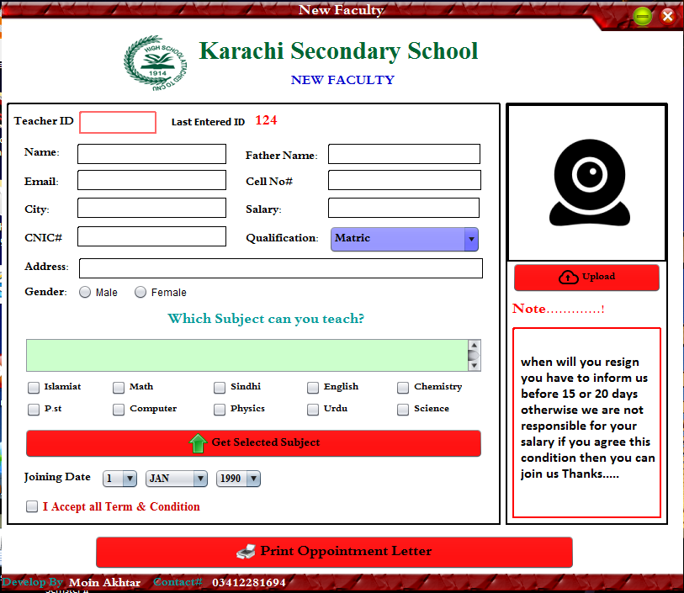

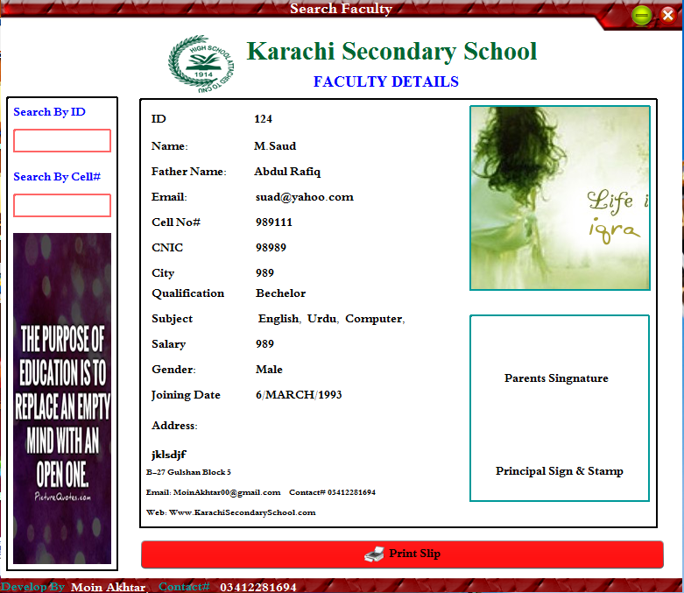

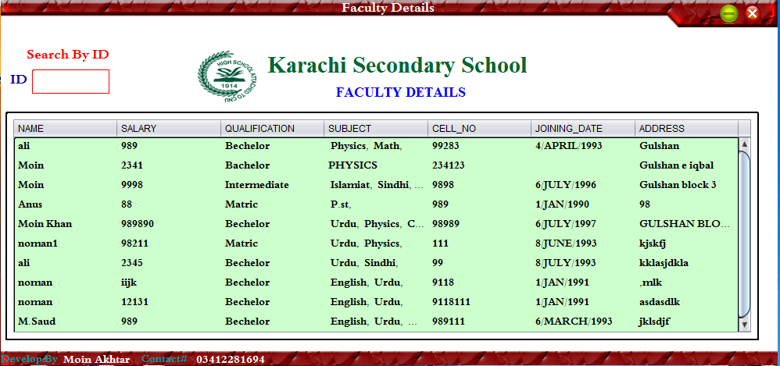



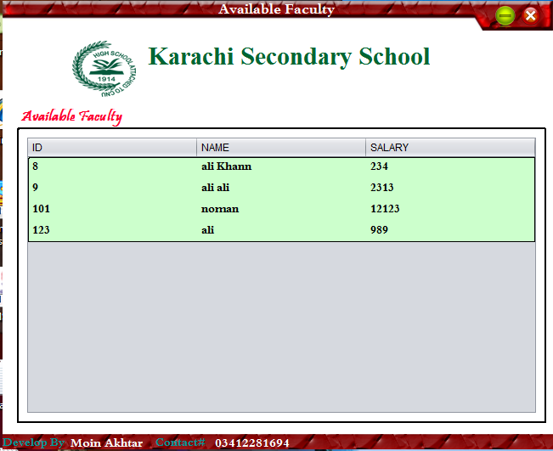

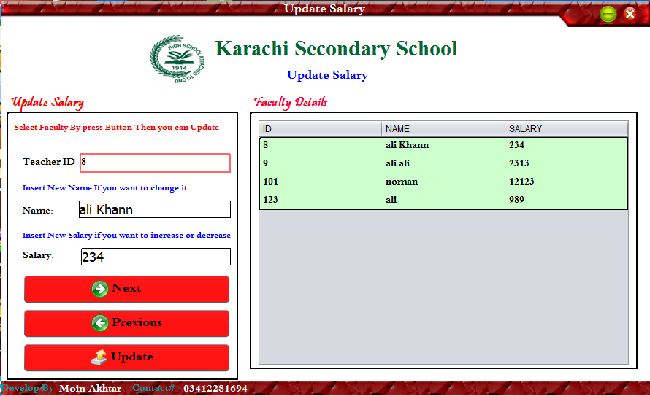

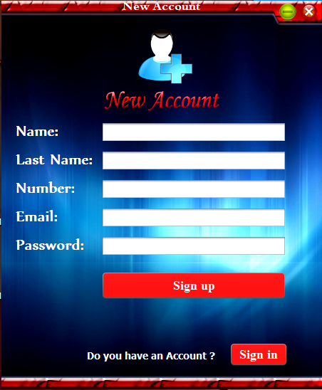

# Database Name “MOIN”

## Login/SingUp Form Table Structure Table name

## “LOGIN”

|  |  |  |  |
| --- | --- | --- | --- |
| Column | Type | Null | Default |
| User_Name | varchar(45) | No |  |
| Password | Varchar(45) | No |  |
| F_Name | varchar(30) | yes |  |
| Number | varchar(11) | yes |  |
| Email | varchar(45) | yes |  |

## Login Form Table Structure Table name

## “LOGIN_DETAIL”

|  |  |  |  |
| --- | --- | --- | --- |
| Column | Type | Null | Default |
| Name | Varchar(25) | Yes |  |
| Date | Date | No |  |

## Admission Form Table Structure Table name

## “ADMISSION”

|  |  |  |  |  |
| --- | --- | --- | --- | --- |
| Column | | Type | Null | Default |
| ID | | int(10) | No |  |
| Name | | VarChar(40) | yes |  |
| F_Name | | VarChar(40) | yes |  |
| Email | | VarChar(40) | yes |  |
| Telephone | | VarChar(11) | yes |  |
| Cell_No | | VarChar(7) | No |  |
| Address | | VarChar(120) | yes |  |
| Class | | VarChar(7) | No |  |
| Country | | VarChar(20) | Yes |  |
| City | | VarChar(20) | Yes |  |
| Date_of_Birth | | VarChar(30) | Yes |  |
| Occupation |  | VarChar(50) | yes |  |
| Admission_Date |  | VarChar(10) | Yes |  |
| Photo |  | BLOB(2147483647) | No |  |
| Gender |  | VarChar(6) | Yes |  |
| Amount |  | VarChar(10) | Yes |  |

## Faculty Table structure Table Name

## “FACULTY”

|  |  |  |  |
| --- | --- | --- | --- |
| Column | Type | Null | Default |
| ID | int(10) | No |  |
| Name | VarChar(32) | yes |  |
| F_Name | VarChar(32) | yes |  |
| Email | VarChar(41) | No |  |
| CNIC | VarChar(14) | No |  |
| Cell_No | VarChar(11) | No |  |
| Address | VarChar(120) | No |  |
| Gender | VarChar(8) | **yes** |  |
| Class | VarChar(7) | No |  |
| Subject | VarChar(100) | Yes |  |
| City | VarChar(20) | Yes |  |
| Joining Date | VarChar(20) | Yes |  |
| Resign_Date | VarChar(10) | yes |  |
| Salary | VarChar(20) | No |  |

## Fees Table structure Table Name

## “FEES”

|  |  |  |  |
| --- | --- | --- | --- |
| Column | Type | Null | Default |
| ID | int(10) | No |  |
| Name | Varchar(45) | Yes |  |
| Class | Varchar(10) | Yes |  |
| Jan | Varchar(10) | Yes |  |
| Feb | Varchar(10) | Yes |  |
| Mar | Varchar(10) | Yes |  |
| Apr | Varchar(10) | Yes |  |
| May | Varchar(10) | Yes |  |
| June | Varchar(10) | Yes |  |
| July | Varchar(10) | Yes |  |
| Aug | Varchar(10) | Yes |  |
| Sept | Varchar(10) | Yes |  |
| Oct | Varchar(10) | Yes |  |
| Nov | Varchar(10) | Yes |  |
| DECE | Varchar(10) | Yes |  |
| Amount_Jan | Varchar(20) | Yes |  |
| Amount_Feb | Varchar(20) | Yes |  |
| Amount_Mar | Varchar(20) | Yes |  |
| Amount_Apr | Varchar(20) | Yes |  |
| Amount_May | Varchar(20) | Yes |  |
| Amount_Jun | Varchar(20) | Yes |  |
| Amount_Jul | Varchar(20) | Yes |  |
| Amount_Aug | Varchar(20) | Yes |  |
| Amount_Sept | Varchar(20) | Yes |  |
| Amount_Oct | Varchar(20) | Yes |  |
| Amount_Nov | Varchar(20) | Yes |  |
| Amount_Dec | Varchar(20) | Yes |  |

## Teacher Salary Table structure Table Name

## “SALARY”

|  |  |  |  |
| --- | --- | --- | --- |
| Column | Type | Null | Default |
| ID | int(10) | No |  |
| Name | VarChar(20) | Yes |  |
| Salary | Varchar(10) | Yes |  |

## Admin Panel Table structure Table Name

## “ADMIN”

|  |  |  |  |
| --- | --- | --- | --- |
| Column | Type | Null | Default |
| FeesIncome | Int(10) | Yes |  |

**DEVELOPT BY:**  **MOIN AKHTAR Facebook: fb.com/moinakhtar123**

**CELL NO# 03412281694**

**TEACHER: ALI ZAHID**

**APTECH GULSHAN**